
Technological Institute of the Philippines
938 Aurora Boulevard Cubao, Quezon City

ITE 010 – INTRODUCTION TO HUMAN-COMPUTER INTERACTION
Discussion 4.1 Human Interface Guidelines

Name: Aristotle Buenaventura
Section: IT12S1

Research some Human Interface Guidelines that we can use in designing mobile applications.

Human interface guidelines are software improvement records that offer application designers a bunch of suggestions. They plan to improve the experience for the users by making application interfaces more natural, learnable, and steady. Most aides restrict themselves to characterizing a typical look and feel for applications in a specific work area climate. The aides list explicit approaches. Arrangements are in some cases dependent on studies of human PC collaboration; however, most depend on shows picked by the stage engineers' preferences.
The focal point of it is to establish a predictable encounter across the climate, including the applications and different instruments being utilized. This implies both applying a similar visual plan and making reliable admittance to and conduct of basic components of the interface – from straightforward ones like catches and symbols up to more intricate developments, for example, exchange boxes.

Below are the eight rules for perfect mobile design based on Uxdesign.cc
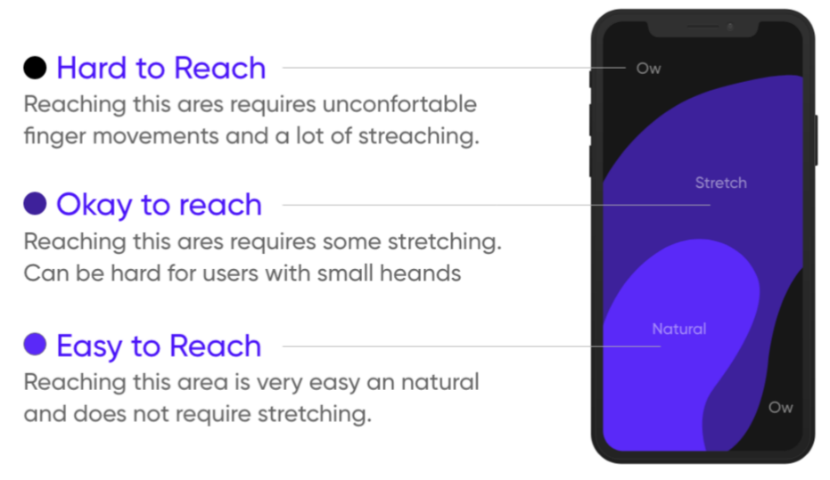
- Reach area – thumb area
Thumb Zone: how easy it is for our thumbs to tap areas on a phone’s screen.

- Platform Guidelines
Use the right design system iOS android have a different user base. Also never carry UI elements from e platform to another.
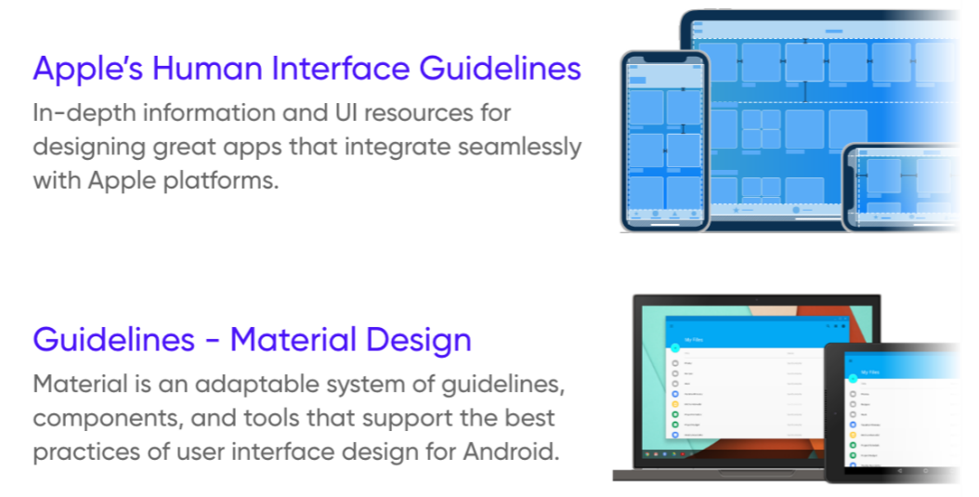

- Think device first
Be aware of the “unsafe areas” (notch, camera punch-hole, etc.)
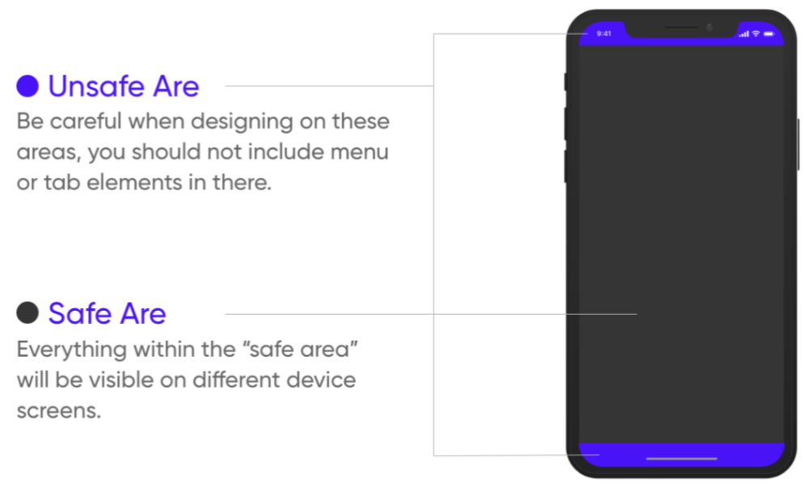

- Font Type and Size
Different fonts can evoke different emotions and provide easy readability at the same time.
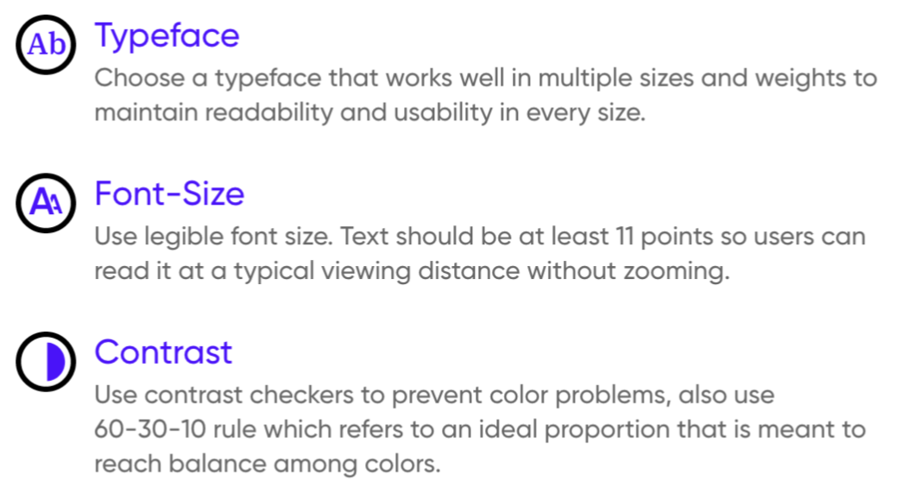

- Call to Action (Buttons)
Design finger-friendly buttons. Mistaken taps often happen because of small touch controls. Create controls that measure at least 10–12 mm (40px) so they can be accurately tapped with a finger.
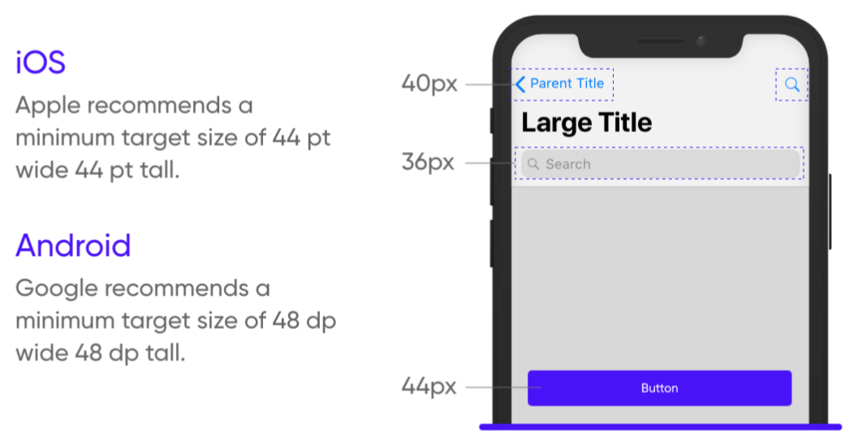

- Long-Scroll Problem
Keep screens as short as possible, using cards with a tap to expand feature or by breaking tasks into screens.
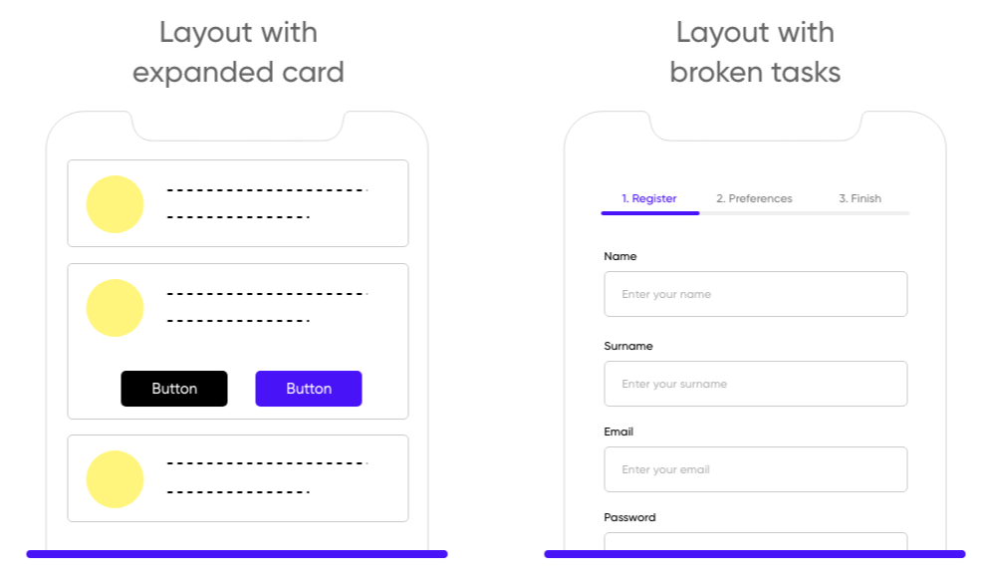

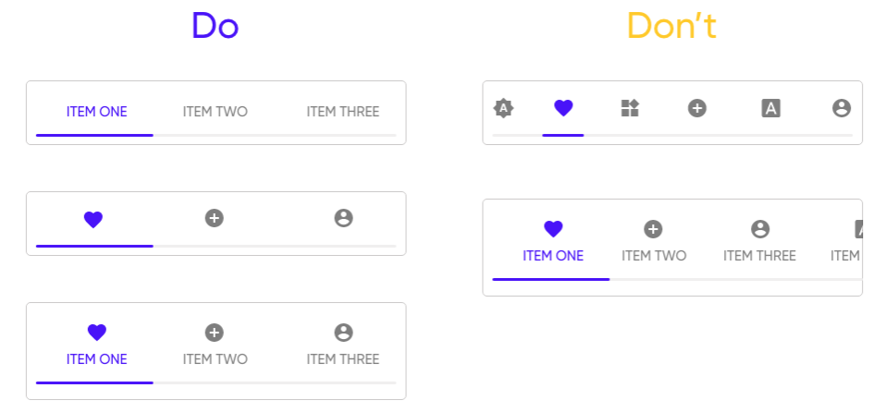
- Tab Bars
Tab bars are part of every app; design clear and clean tab bars also name all tabs whenever possible for better user experience.

- Gesture
Tap or swipe mobile gestures? It’s really important to choose wisely because using the wrong type of gesture can lead to a broken UX.
